Honeysuckle Herald
Resident Edition
October – November 2017
So much going on…where do we start
Welcome to the warmer weather although still a little spasmodic as I write this report. We are constantly monitoring our processes and always looking at best practice. Staff have been adaptive and we are always open to any ideas or suggestions.
Violet Town Bush Nursing Home has trialled a state of the art shower chair which is both oh&s Friendly for staff and less stressful for residents. The trial has been very successful so this chair will be purchased. King Single beds have been purchased for some of our larger residents some of our donated monies will help towards both the purchase of the Shower Chair and beds. The Friends of VTBNC have kindly offered to donate funds to purchase two beds.
I have done some preliminary statistics on our Solar Panels at both Violet Town and Bendigo.
The predicted savings are being met and our September bill at Bendigo was about ½ of the usage for some month last year. This will help achieve our long term financial sustainability as energy prices rise.
The Op Shop kindly donated $1000 to our Wetlands Project and I we were given a cheque for $5000 from Sheep Pen Landcare Group which will now really help complete the project.
Just a reminder the AGM is approaching again and will be held at 7.30pm 13/11/2017 Monday night. If anyone would like a copy of the financials before the meeting please contact me.
Regards
Barry Hobbs
CEO
Honeysuckle Regional Health
There’s been much on our calendar in the last month with Kids Kinda visits, an eve out at the local to check out the Pot and Parma deal, creating for the Euroa Show, Wheel Chair walks, Music with Margaret as well as our usual program’s and now as the weather warms a few additions have been introduced such as the Wet Land Walks with Roger and frog watch and Strength training in our Gym, so if you’re interested let Madonna know. Just a caution for those who like to take a walk as the weather warms you may come across a wriggley (snake) please notify staff should this occur. The outdoor area behind the Hostel Unit and courtyard adjoining is also a concern as the pavers are lifting and a hazard, we ask that you refrain from walking in this area until repaired.
Some of our programs have not been available and we apologise for any inconvenience, as most are aware one of our favourite friends has been away due to illness and this has put a hole in our man power fortunately there is good news as Alyson is expected to return on the 14th of November, looks like a good excuse Cake and Coffee! We added to our team a new addition to our team -Vicki who could fill some of the gaps in our programs. Welcome!
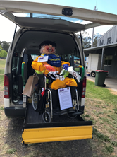
Our Scare Crow VIOLET was again entered into the EUROA show and received an honourable mention for her community commitment as volunteer expertise much thanks to family and residents who assisted in creating her – further confirmation that we are very much part of our community as Robbie Rae provided the CFA overalls and Robyn Harrison of the Violet Town Pool swim stuff both these ladies are family of residents. This leads beautifully into our big news and that is we are to have our home play a small part in the ABC television Program “Back Roads” with filming soon and the showing in January 2018. Looks like a red-carpet celebration…congratulations to Lorna Bamford on her First Prize for her entry.
Recently we have been fortunate to receive funds that were given to us from families who have lost their loved ones who called VTBNC home these monies will go to enhance our Lifestyle programs and the living environment. Much thanks to:
Anna’s Kungal’s dearest friend Sandra as their funds will go towards our Christmas entertainment and celebrations.
Leo Donahue’s family the Smyth’s as their funds have purchased a Smart Television for our main lounge.
Phil James family for the IPODS that will provide residents with the opportunity to experience our Music Memory Program. For more information go to the following web address: www.sbs.com.au.article 2016/01/12.
Further generosity was extended this week when Zelma Heckenberg’s family brought in 36 brilliantly decorated cupcakes as well as a donation that has purchased a Portable CD player with a USB port, this will be most useful for individual playlists and relaxation as well as Palliative Care.
The Open Minds Active Lives initiative continues in its progression towards “Best Practice “in the area of Dementia, one of the latest introductions to our home has been 2 Silkie chicken “Violet & Crumble” these girls visit weekly and are a welcome addition to our already expanding brood. We also adopted Spotty Dotty – a Wyndote Girl from the Hen House of Margaret and Kel Davies who was born with a funny Leg. Should you want to know more about this program have a look at www.sbs.com.au.article? 2016/02/23
So far, we have received 3 Christmas Cards with our Christmas Card Swap Program- this program involves residents in sending Christmas Cards to Homes like our own worldwide and in return receiving cards.
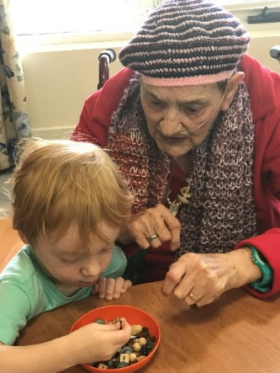
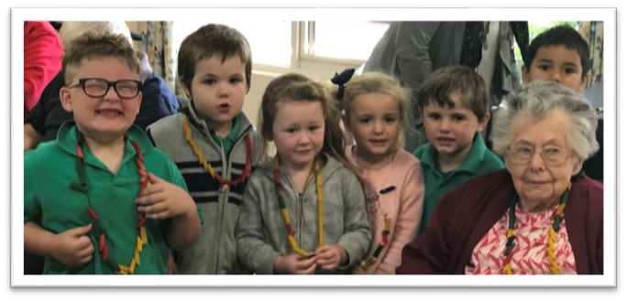
KINDA KIDS …visit and make treasures!

Our monthly takeaway meals have proven to be popular – last month was Chinese and from the number of orders it look like we will keep it on the program as a regular event with Sweet and Sour Battered Pork being the most popular. Please don’t hesitate in suggesting your favourite take away.

Family Gathering with Arlene November 20th
Day Therapy Room @10am
Resident Gathering
December : 8th at 10am in the main lounge

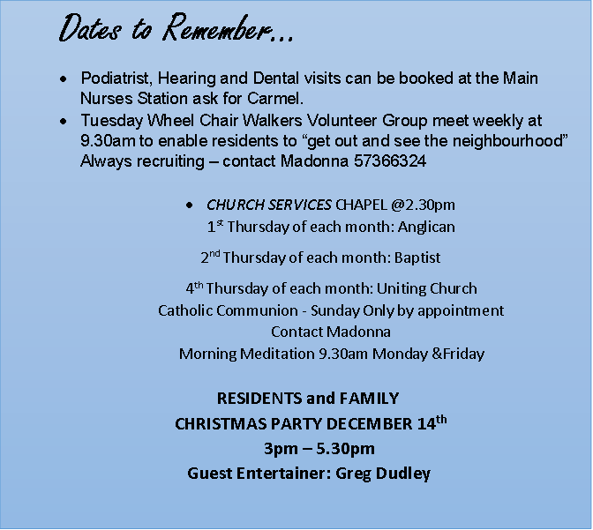
In the spirit of the Spring Racing Carnival an Oaks Day Luncheon was celebrated with Games, a sweep and fashions on the field and a fantastic Chicken and Champers, this is only the beginning of the Celebration Season as Christmas is not too far away. Our Family and Residents Christmas Party is set for December 14th starting at 3pm with a Finger Food served as we Greg Dudley entertains with popular tunes and a few Christmas Carols. Notification of this event is attached, please send back your RSVP by December 4th to assist us with catering.

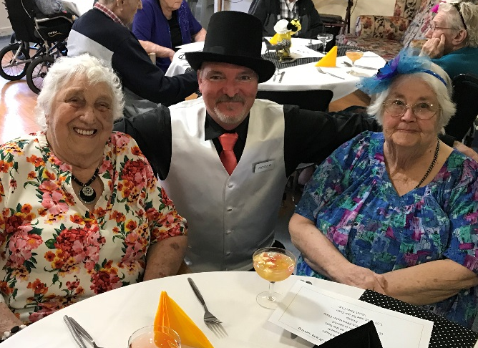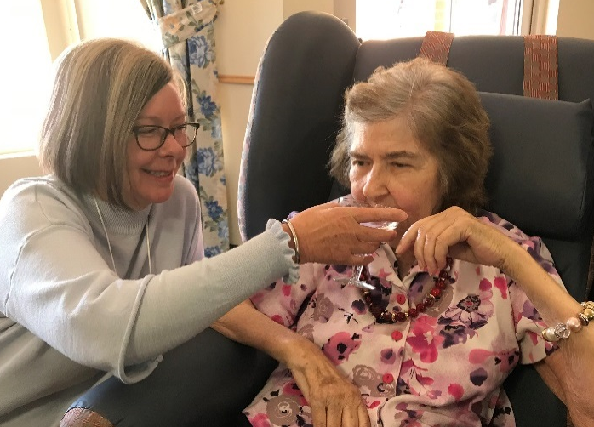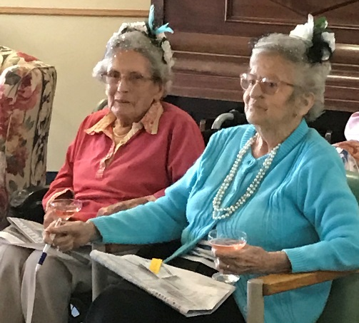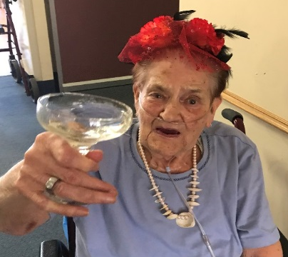
Melbourne Cup Week Photo Gallery

.

